Did you know that you can support the Communication Advocacy Network (CAN) every time you shop at Amazon?
Logo of AmazonSmile “You shop. Amazon Gives.”

Every time you shop at smile.amazon.com, 0.5% of the purchase price from your eligible AmazonSmile purchases will be donated to the Communication Advocacy Network (CAN) by the AmazonSmile Foundation. By shopping at smile.amazon.com, you can support CAN and enjoy the same exact same shopping experience as amazon.com. Simply select “Communication Advocacy Network”. from Amazon’s list of charitable organizations and begin shopping. It’s that easy.

First time using AmazonSmile?
1. Sign in to smile.amazon.com on your desktop or mobile phone browser. You will be prompted to select a charity of your choice.
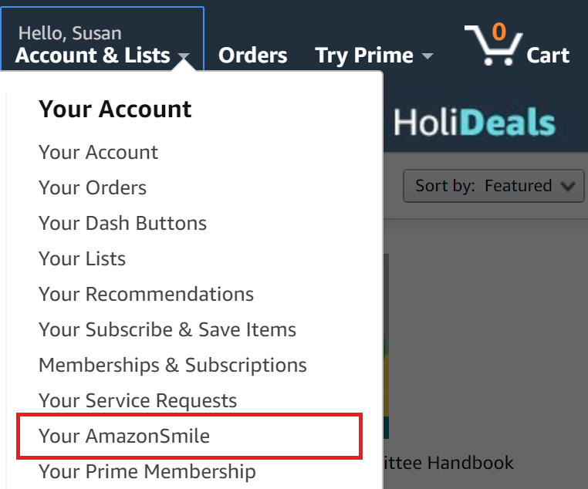
Go to “Your AmazonSmile” under “Your Account & Lists”

2. Type in “Communication Advocacy Network” in the search bar at the bottom of the page.
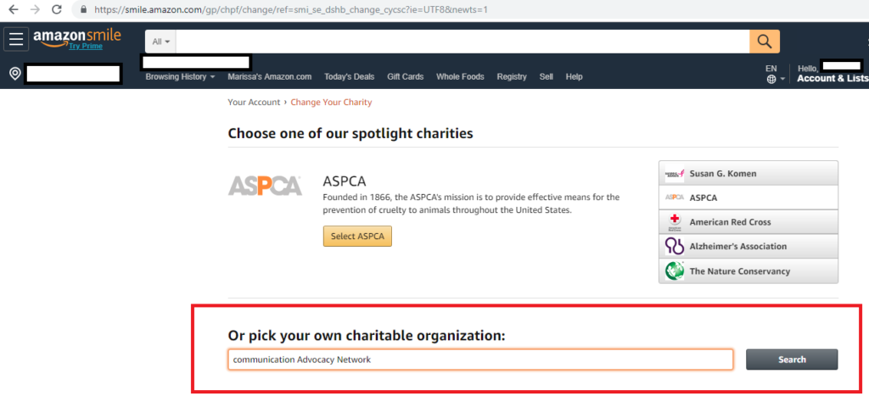
Screenshot of the Amazon Smile Search Bar for “Pick your own charitable organization”

3. In the search results, look for Communication Advocacy Network and click Select.
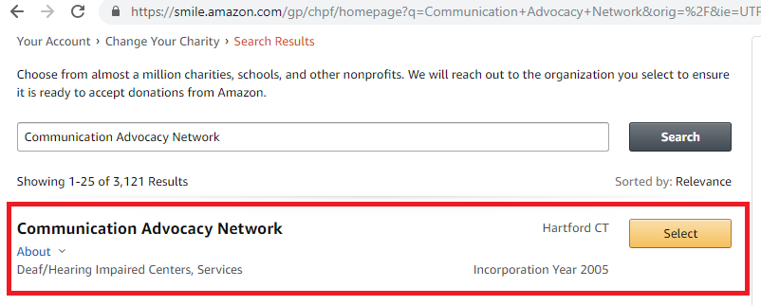Screenshot of AmazonSmile “Communication Advocacy Network” result in the Charity search bar

4. Finally, you are all done. Now each purchase you make through AmazonSmile. will donate money to CAN!
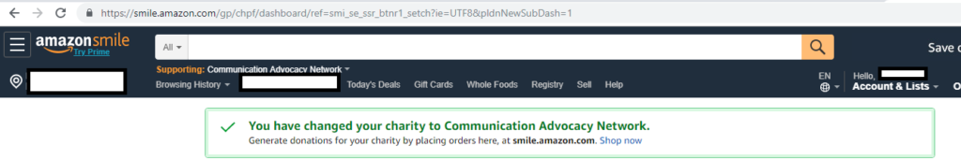Screenshot of a confirmation message from AmazonSmile “You have changed your charity to Communication Advocacy Network.”

For more information about the AmazonSmile program, go to https://smile.amazon.com/about

